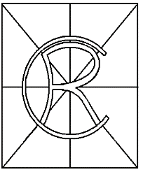
Rosscarrock Community Association
Special Resolution

Whereas the Society known as the Rosscarrock Community Association is a registered Society under the provisions of the Societies Act in the Province of Alberta and,
Whereas there is provision in both the Act (s. 15) and the Association Bylaws (s. 8 (9.1)) that bylaws be amended by a Special Resolution,

Be it Resolved,

That the members present at this Special Meeting, held on May 30, 2017 at 7:00 pm in the City of Calgary, do authorize the Board to:
- Adjust Articles One (1), Three (3), Four (4) and Article Eight (8) as recommended by the Bylaw Review Committee in the document Bylaw Adjustment Recommendations - 2017.

I hereby certify that the following special resolution was passed at a meeting of the members of the Rosscarrock Community Association held on May 30, 2017.

Ronald Waters
President
Rosscarrock Community Association

